Requirement List of “Easy Send” function

By Sapumal

내용

1. Requirement history 2

2. Requirements Purpose 3

3. Requirements List 3

# Requirement history

|  |  |  |  |  |
| --- | --- | --- | --- | --- |
| Version | Date | Author | Type | Contents |
| V1.0 | 2021-12-26 | Subash/ Sapumal | Easy Send | Customer should be allowed to do transactions in Korea and Overseas without entering receiver details |
|  |  |  |  |  |

# Requirements Purpose

The Main purpose of this new Easy send function is to allow customers to do local and international transfers quickly without adding receiver details, so receiver can receive money any time in any bank or send to a different person to receive money in that person’s account. Such a cash cheque

Target customers,

1. Sending E-commerce payments
2. Onetime payment to new receiver

# Requirements List

Local Transfer

1. Allow customer to choose “send now”, “Schedule”, “Easy Send” functions after choosing local transfer
2. In Easy Send tab, customer should be allowed to select debit account and the amount
3. Easy send function agreement should be included before click “Agree and Send” button
4. After entering OTP, receipt should be shown with the transaction link
5. GME will deduct the money and keep the transaction in a different table until receiver enter details and receive money
6. Copy link button and share link button should be included in the receipt
7. If customer click share button, share options should be shown according to installed chat messengers in the phone
8. If receiver click on the link “Receive Easy Send” page should be shown
9. In receive easy send page, amount and expiry date/ time should be shown
10. In receive easy send page, allow customer to choose bank and enter account number
11. Show recipient name if click continue in receive page
12. If customer confirm the name and click proceed, transaction should be successful and go to receipt page
13. If the transaction is failed, should show error message including contact GME button
14. If customer click “Contact GME”, should show channel talk and all cs phone numbers as we cannot assume the receiver’s nationality
15. If the transaction is successful, status in senders account should be updated to “paid”
16. Business team will decide the maximum waiting time for transactions (Approx. 30 days)

International Transfer

1. Allow customer to choose “send now”, “Schedule”, “Easy Send” functions after choosing send money button
2. In Easy Send tab, customer should be allowed to select recipient country, payout mode
3. When click submit button app should be directed to “Choose Payment Method” page
4. When the customer selects payment mode, app should be directed to amount calculation menu
5. If customer enter sending amount or receiving amount and continue, direct to summery page
6. Easy send function agreement should be included before click “Agree and Send” button
7. After entering OTP, receipt should be shown with the transaction link
8. GME will deduct the money and keep the transaction in a different table until receiver enter details and receive money

(GME will have to fund and deal accordingly, otherwise will have to bear the currency exchange loss)

1. Copy link button and share link button should be included in the receipt
2. If customer click share button, share options should be shown according to installed chat messengers in the phone
3. If receiver click on the link “Receive Easy Send” page should be shown
4. In receive easy send page, amount and expiry date/ time should be shown
5. In receive easy send page, allow customer to add all the necessary details according to the partner’s requirement.
6. If the name verification is available to the recipient country, show/ verify recipient name when submit receiver’s info
7. Then direct to summary page and easy send agreement should be available to read if the receiver wants to read
8. If customer click on “Agree and send”, transaction should be successful and go to receipt page
9. If the transaction is failed, should show error message including contact GME button
10. If customer click “Contact GME”, should show channel talk and all cs phone numbers as we cannot assume the receiver’s nationality
11. If the transaction is successful, status in senders account should be updated to “paid”
12. Business team will decide the maximum waiting time for transactions (Approx. 7 days)

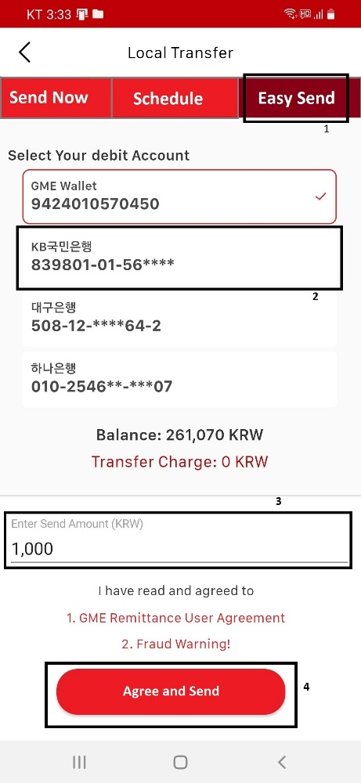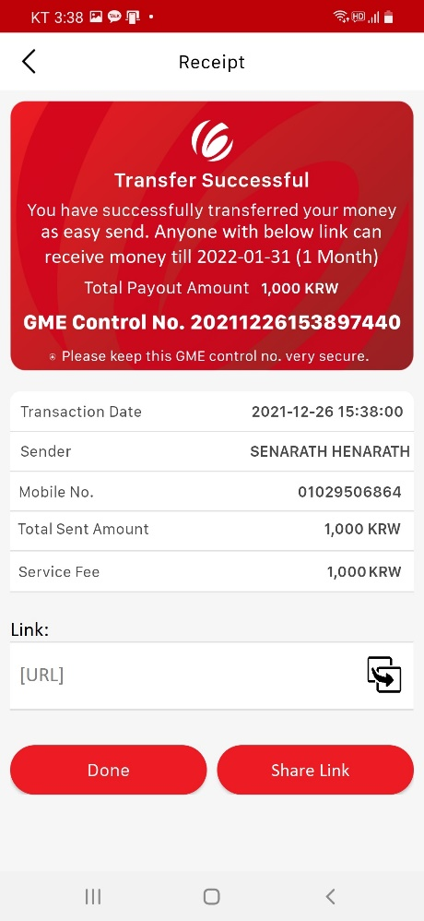**Mobile Application – Local Transfer  
Sending:**

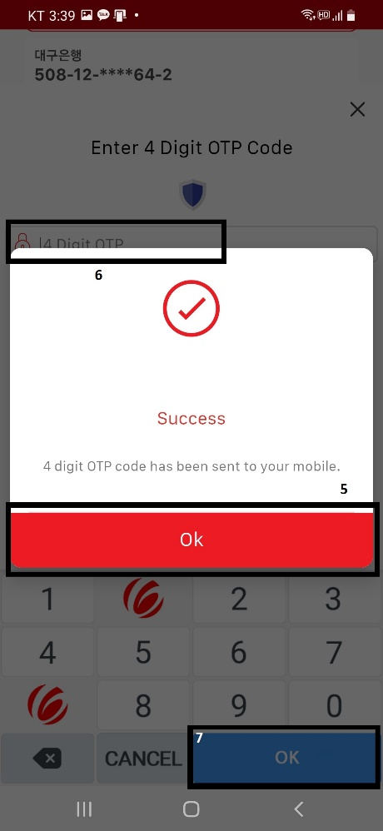

**Receiving:**

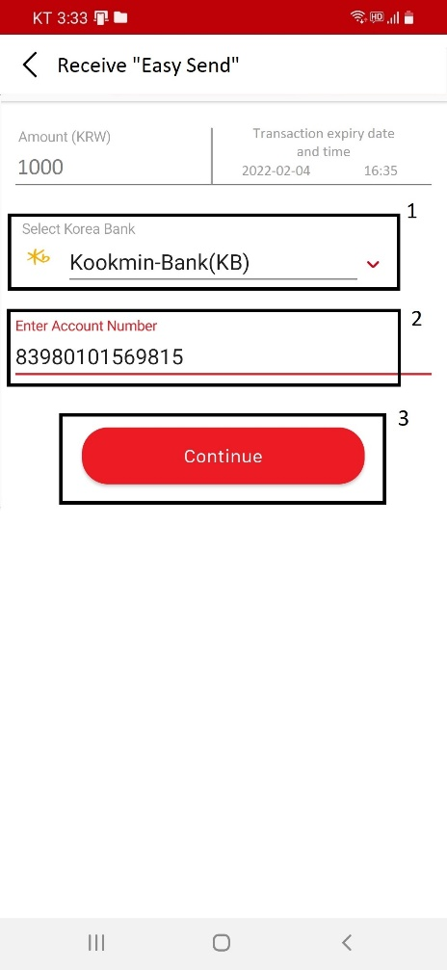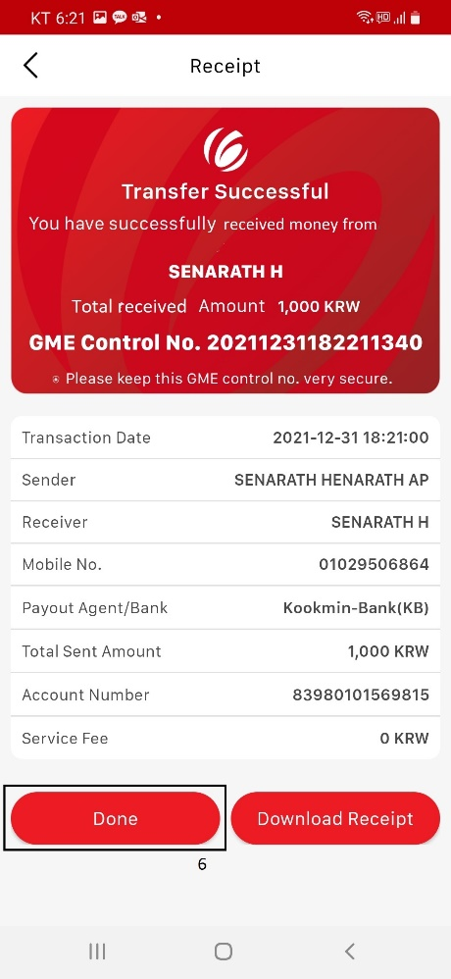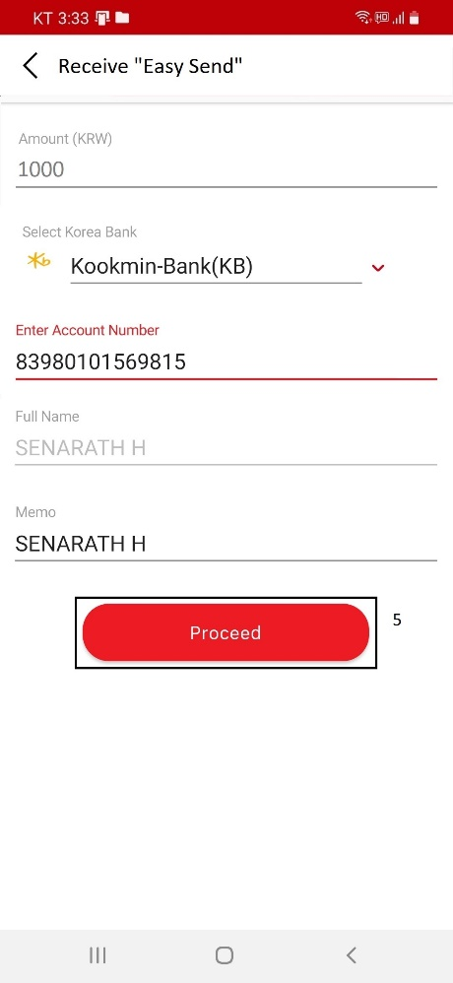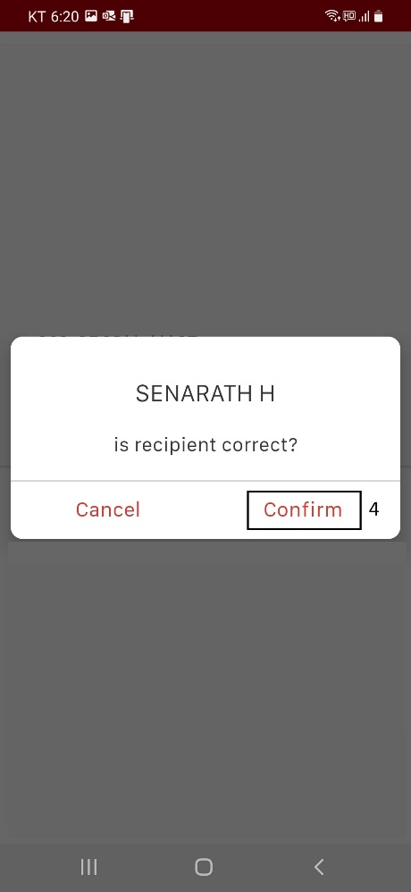success case:

**Receiving:**

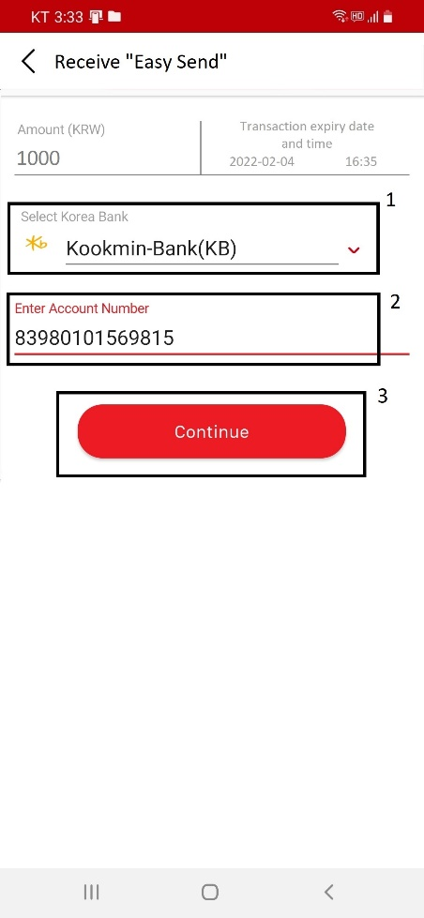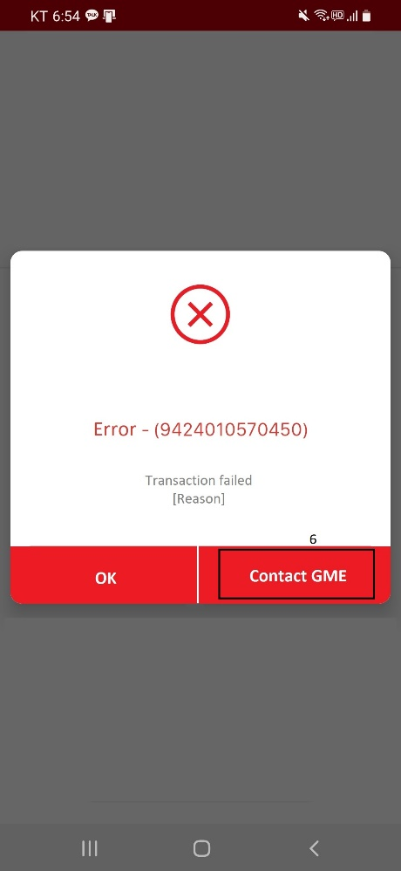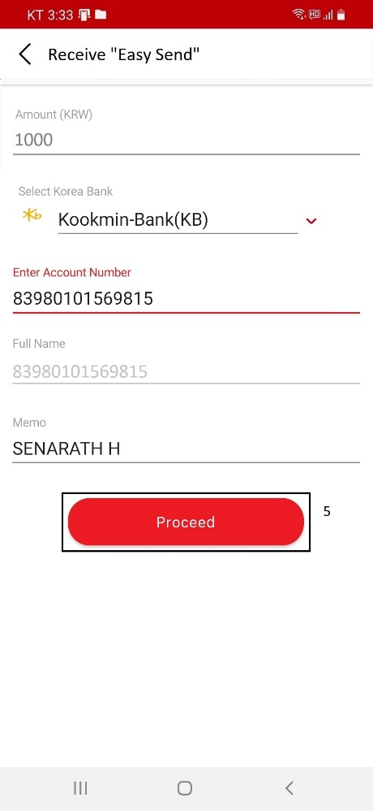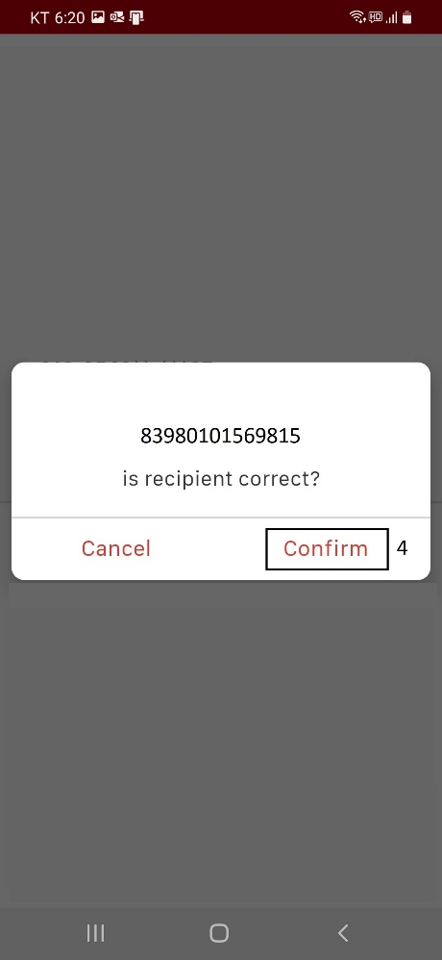Fail case (wrong account details):

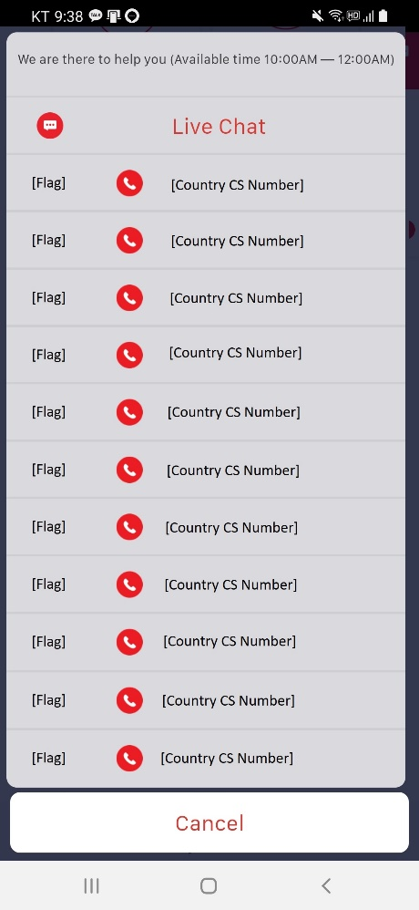

**Mobile Application – Overseas Transfer**

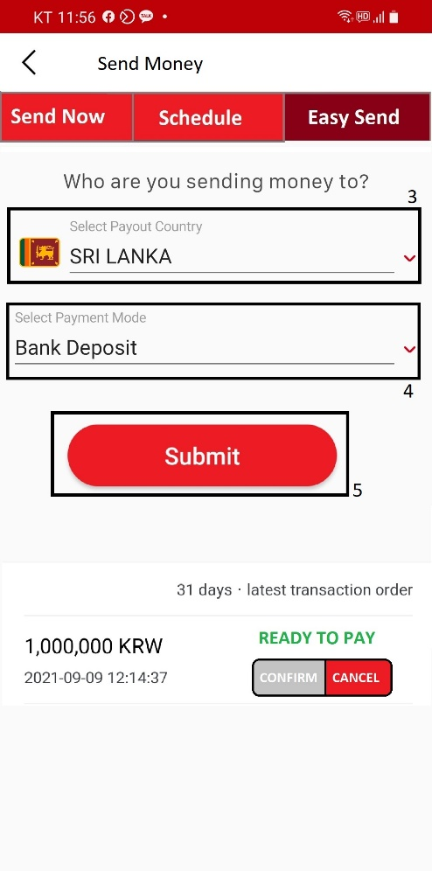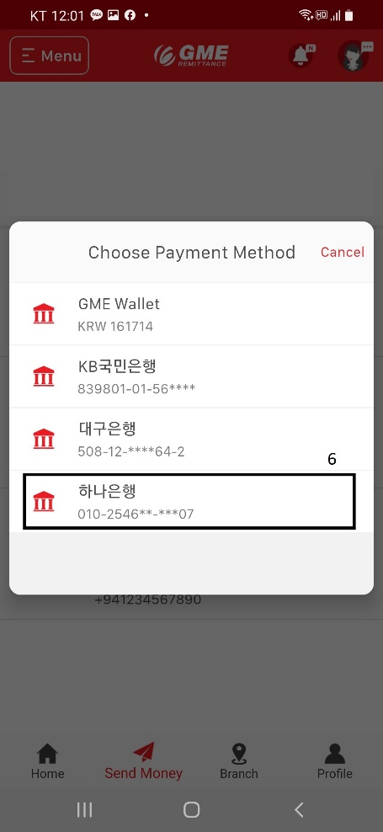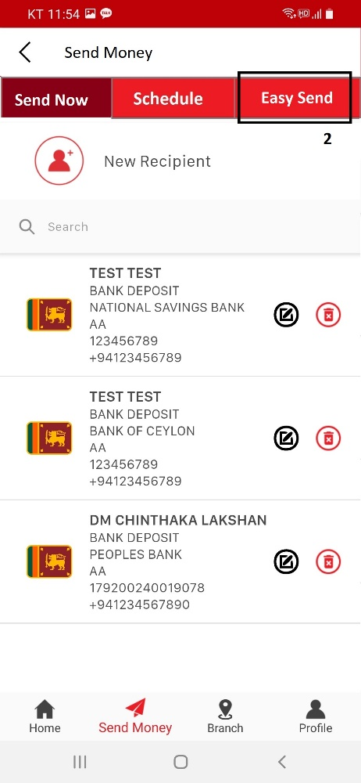**Sending:**

**Receiving:**

[Success]

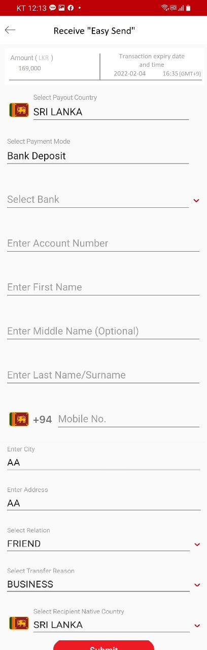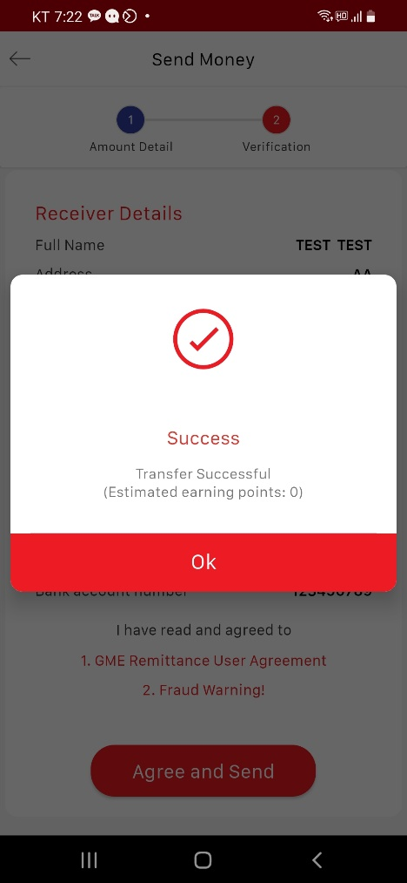

**Receiving:**

[Fail]



